|  |  |  |  |  |  |  |  |  |  |
| --- | --- | --- | --- | --- | --- | --- | --- | --- | --- |
| **SCHOOL OF COMPUTER SCIENCE AND ARTIFICIAL INTELLIGENCE** | | | | | **DEPARTMENT OF COMPUTER SCIENCE ENGINEERING** | | | | |
| **ProgramName:**B. Tech | | | | **Assignment Type: Lab** | | | **AcademicYear:**2025-2026 | | |
| **CourseCoordinatorName** | | | | Venkataramana Veeramsetty | | | | | |
| **Instructor(s)Name** | | | | |  | | --- | | Dr. V. Venkataramana (Co-ordinator) | | Dr. T. Sampath Kumar | | Dr. Pramoda Patro | | Dr. Brij Kishor Tiwari | | Dr.J.Ravichander | | Dr. Mohammand Ali Shaik | | Dr. Anirodh Kumar | | Mr. S.Naresh Kumar | | Dr. RAJESH VELPULA | | Mr. Kundhan Kumar | | Ms. Ch.Rajitha | | Mr. M Prakash | | Mr. B.Raju | | Intern 1 (Dharma teja) | | Intern 2 (Sai Prasad) | | Intern 3 (Sowmya) | | NS_2 ( Mounika) | | | | | | |
| **CourseCode** | | | 24CS002PC215 | **CourseTitle** | | AI Assisted Coding | | | |
| **Year/Sem** | | | II/I | **Regulation** | | R24 | | | |
| **Date and Day**  **of Assignment** | | | Week2 - Wednesday | **Time(s)** | |  | | | |
| **Duration** | | | 2 Hours | **Applicableto**  **Batches** | |  | | | |
| **AssignmentNumber:4.3**(Present assignment number)/**24**(Total number of assignments) | | | | | | | | | |
|  | | | | | | | | | |
|  | **Q.No.** | **Question** | | | | | | ***ExpectedTime***  ***to complete*** |  |
|  | 1 | Lab 4: Advanced Prompt Engineering – Zero-shot, One-shot, and Few-shot Techniques  **Lab Objectives:**   * To explore and apply different levels of prompt examples in AI-assisted code generation. * To understand how zero-shot, one-shot, and few-shot prompting affect AI output quality. * To evaluate the impact of context richness and example quantity on AI performance. * To build awareness of prompt strategy effectiveness for different problem types.   **Lab Outcomes (LOs):**  After completing this lab, students will be able to:   * Use zero-shot prompting to instruct AI with minimal context. * Use one-shot prompting with a single example to guide AI code generation. * Apply few-shot prompting using multiple examples to improve AI responses. * Compare AI outputs across the three prompting strategies.   **Task Description#1**   * Zero-shot: Prompt AI to write a function that checks whether a given year is a leap year.   **Expected Output#1**   * AI-generated function with no examples provided   **Task Description#2**   * One-shot: Give one input-output example to guide AI in writing a function that converts centimeters to inches.   **Expected Output#2**   * Function with correct conversion logic   **Task Description#3**   * Few-shot: Provide 2–3 examples to generate a function that formats full names as “Last, First”.   **Expected Output#3**   * Well-structured function respecting the examples   **Task Description#4**   * Compare zero-shot and few-shot prompts for writing a function that counts the number of vowels in a string.   **Expected Output#4**   * Functional output and comparative reflection   **Task Description#5**   * Use few-shot prompting to generate a function that reads a .txt file and returns the number of lines.   **Expected Output#5**   * Working file-processing function with AI-guided logic   **Note: Report should be submitted a word document for all tasks in a single document with prompts, comments & code explanation, and output and if required, screenshots**  **Evaluation Criteria:**   | **Criteria** | **Max Marks** | | --- | --- | | Zero Shot (Task #1) | 0.5 | | One Shot (Task#2) | 0.5 | | Few Shot (Task#3 & Task #5) | 1.0 | | Comparison (Task#4) | 0.5 | | **Total** | **2.5 Marks** | | | | | | | Week2 - Wednesday |  |

**NAME**:J.SAI.GANESH **Date**:20-08-2025  
**ROLL NO:**2403A51301

**#TASK1  
Prompt :** *Generate a Python function that checks if a given year is a leap year.*

**Code: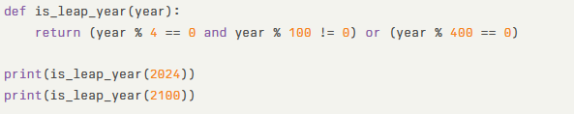 out put: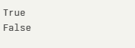 Observation:** AI inferred the rules without examples.  
Zero-shot worked because leap year logic is well-defined.

**#TASK2  
one-shot-prompt:** *Convert 100 cm to inches → output should be 39.37. Write a Python function that does this conversion.* ***code: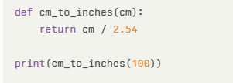 out put:*****Observation:** One example guided the correct conversion factor.  
The function returned accurate decimal conversion.

**#TASK3  
Few-shot-Prompt**: Write a Python function that formats names as 'Last, First'.  
 *Examples:  
Input: "Albert Einstein" → Output: "Einstein, Albert"  
Input: "Isaac Newton" → Output: "Newton, Isaac"  
Write a function that formats names as Last, First.*

**Code**:  
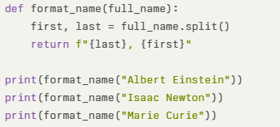  
**out put: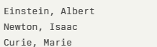 Observation:**  
Few-shot guided exact formatting pattern.  
It generalized reliably to new names.

**#TASK4  
zero-shot-prompt:** *Write a function that counts vowels in a string.****code:****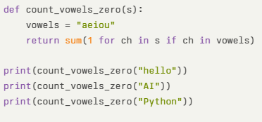* ***out put:****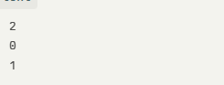* ***Few-shot-Prompt:*** *Write a function that counts vowels in a string.  
Examples:  
Input: "hello" → Output: 2  
Input: "AI" → Output: 2  
Write a Python function that generalizes this pattern.*

***Code: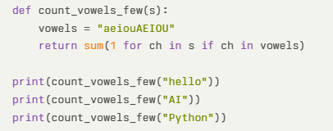 out put: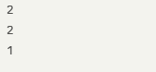 Observation:*** shot produced a working solution but fewer checks.  
Few-shot ensured examples matched exactly, reinforcing Zero correctness.

**#TASK5:  
Few-shot-prompt:** Write a function that reads a .txt file and returns the number of lines.  
Examples:  
File with 3 lines → Output: 3  
File with 5 lines → Output: 5  
**code: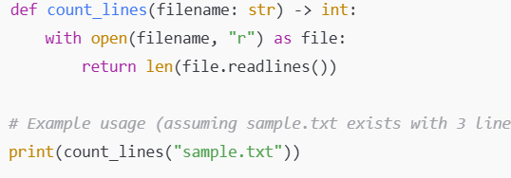 out put:** **Observation:** Few-shot made the AI infer file handling logic.  
The function is concise and works reliably for text files.